1. Define the concept of a unit vector and explain its significance in vector operations.

Calculate the angle between two given vectors. The two vectors are,

a = $\vec{i}$ + 2 $\vec{j}$ and

b = 9 $\vec{i}$ + 3 $\vec{j}$

Ans: A unit vector is a vector with a magnitude of 1. It is often denoted by a hat symbol and is used to represent direction in space. In vector operations,

unit vectors are significant because they allow us to separate information about direction from information about magnitude, making calculations more

intuitive and efficient.

cos Ɵ = $\frac{ \vec{a }.* \vec{b }}{‖ \vec{a }‖ ‖ \vec{b }‖ }$ = $\frac{\left(1*9\right)+(2*3)}{\sqrt{1+4} \sqrt{81+9}}$

= $\frac{15}{\sqrt{5} \sqrt{90}}$ = $\frac{15}{5\sqrt{18}}$

= $\frac{3}{3\sqrt{2} }$ = $\frac{1}{\sqrt{2} }$

Hence Ɵ = 45°

B.

Write down all the arithmetic operations possible on vectors.

Find the vector projection of the vector $a=\left[3,4\right]$  on $b=\left[5,-12\right]$

Ans: Arithmetic operations that can be performed on vectors include:

Vector addition: Adding corresponding elements of two vectors to create a new vector.

Vector subtraction: Subtracting corresponding elements of two vectors to create a new vector.

Scalar multiplication: Multiplying a vector by a scalar value to scale its magnitude.

Dot product: Multiplying corresponding elements of two vectors and summing the results.

Cross product: Finding a new vector that is perpendicular to the plane defined by two vectors.

Vector normalization: Dividing a vector by its magnitude to create a unit vector in the same direction.

Vector projection: Finding the component of one vector in the direction of another vector.

Vector reflection: Finding the mirror image of a vector across a specified plane or line.

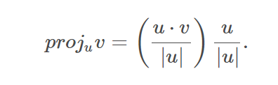 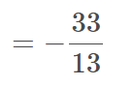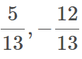 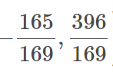

C.

What are local minima and global minima ?

Find out the minima of the following function for the interval ( -5, -2) f(x)=x3+2x

Ans: Local minima and global minima are concepts in optimization and function analysis.

Local Minima: A local minimum is a point on the graph of a function where the value of the function is smaller than the values of the

function at all nearby points. Formally, a point x is considered a local minimum of a function f(x) if there exists a neighborhood around x

such that f(x) is less than or equal to f(y) for all y in the neighborhood. In other words, it is the lowest point in the vicinity of a particular

location. However, it may not necessarily be the lowest point of the entire function.

Global Minima: A global minimum is the lowest value of a function over its entire domain. It is the absolute lowest point of the function and

cannot be surpassed by any other point in the function's domain. Formally, a point x is considered a global minimum of a function f(x) if f(x) is less than

or equal to f(y) for all y in the domain of f(x).

In essence, a local minimum is a point that is lower than its neighboring points, while a global minimum is the lowest point of the entire function. It's important to note that a global minimum is also a local minimum, but not vice versa.

derivative of f(x)

:

critical points by setting f(x) equal to zero:

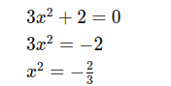

Since x^2 cannot be negative, there are no real solutions for x. Hence, there are no critical points. Since there are no critical points within the interval (−5,−2), we'll evaluate the function f(x) at the endpoints of the interval to determine the minimum:

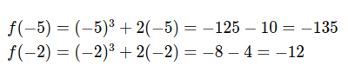

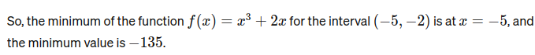

D.

Write the transformation matrix for rotation and reflection of a 2d image.

Ans:

Rotation Matrix (2D):

For rotation of an angle θ counterclockwise about the origin in a 2D plane, the transformation matrix is:

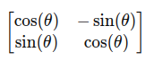

This matrix represents a linear transformation that rotates points in the 2D plane counterclockwise around the origin by an angle θ.

Reflection Matrix (2D):  
For reflection about the x-axis, the transformation matrix is:

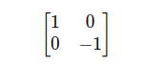

This matrix reflects points in the 2D plane about the x-axis. For reflection about the y-axis, the transformation matrix is:

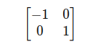

This matrix reflects points in the 2D plane about the y-axis. These transformation matrices can be used to perform rotations and reflections of 2D images by multiplying them with the coordinates of the points in the image.

E.

What are critical points in a function? Find the critical points of the function f(x)=x5−5x4+5x3−1

Ans: Critical points in a function are the values of the independent variable (usually denoted as x) where the derivative of the function is either zero or

undefined. In other words, critical points are the points where the function may have a local minimum, local maximum, or a saddle point.

